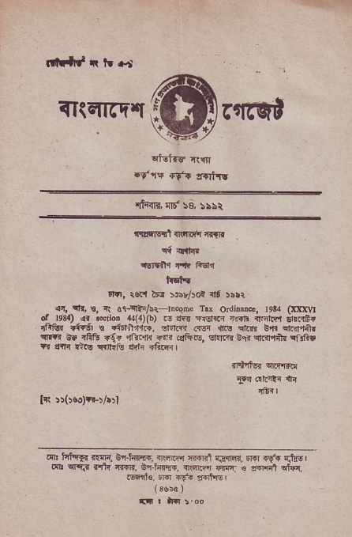
tril||d |t ?t {-t
iiliilrq'q
^{qtEita} {i{n
.f,f., clt lrqtts
^{qtT{ra} 'l!' \s, 55bt
{carlqd clglmtr frllf
c{ lnlir
_{cE} ^{qrlr} fr FEI'I
Itr''
Fri, r'!Fl 16-{ :$r^ot it rr.r
_{{t,} ^{qfr,} €, r! ol-qt"/rr r'cem Trr _{OdmDe.} j93! (m(\4 d le3a) lf &doD .4{4){b) r, _{dEs +rs-€} ^{'r@} nircr dFr{i{ frls {i!si ! drrr'rr.i, arnF .rri _{{rs} dn{r _{6ir} qrrl4in {R 6E rFfr _{+{'} ^{.rrrFrr} {c{ ..q _{G.} ^{q.'lFr} _{er{} qddtu ^{q} fic .r tnr ^{{?lq Krds ati} _{"Ge} L
0{h{@, ilftkr r{{nlr.Er@, Edr.9'{ {.fts I
a{*, $zirffi{, _{{1116{} ^{qq} _{€ mE1} qlrr
FFI1€ Dr{I {{:. a{it'Fl

